Excel Assignment – 9

**Q1. What are the different margins options and do we adjust the margins of the excel worksheet?**

1. Normal
2. Wide.
3. Narrow
4. Custom

**Steps:**

First, we need to select the specific sheet to which we wish to adjust margins. We can select a single sheet or multiple sheets simultaneously as per our needs. Likewise, we can select multiple adjacent or non-adjacent sheets holding down the Ctrl

Once all the desired sheets are selected to apply specific margins, we need to go to the Page Layout tab and click the Margins tool under the Page Setup  
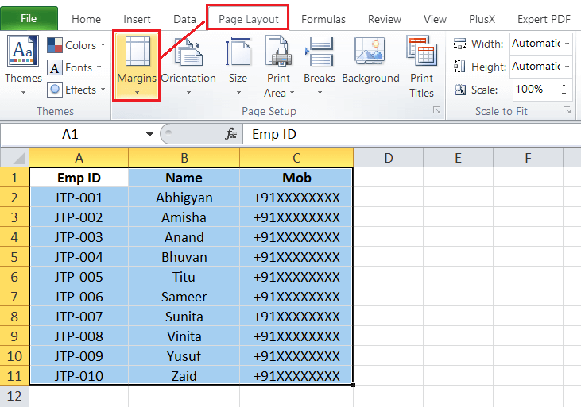

In the next window, Excel displays all the existing margin options. We can click on any predefined margins, such as Normal, Wide, or Narrow. The selected margin will be immediately applied for all the selected sheets within the active workbook.  
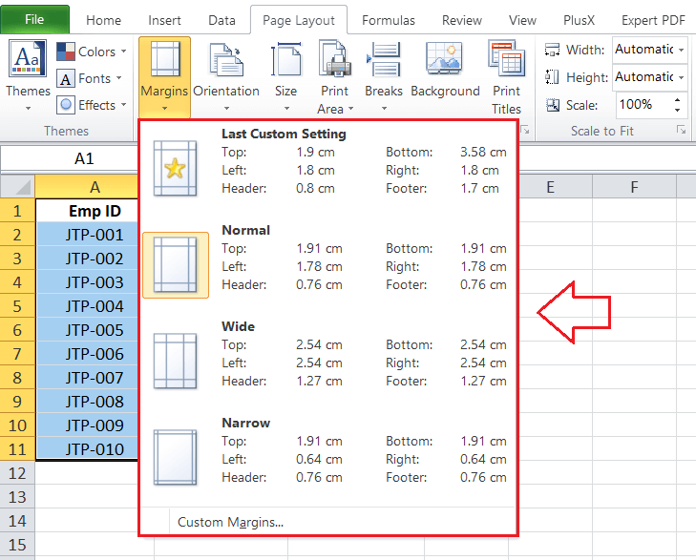

**Q2. Set a background for your table created.**

1. Click the worksheet that you want to display with a sheet background. Make sure that only one worksheet is selected.
2. On the Page Layout tab, in the Page Setup group, click Background.

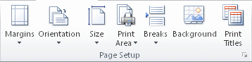

1. Select the picture that you want to use for the sheet background, and then click Insert.

The selected picture is repeated to fill the sheet.

* To improve readability, you can hide cell gridlines and apply solid color shading to cells that contain data.
* A sheet background is saved with the worksheet data when you save the workbook.

To use a solid colour as a sheet background, you can apply cell shading to all cells in the worksheet.

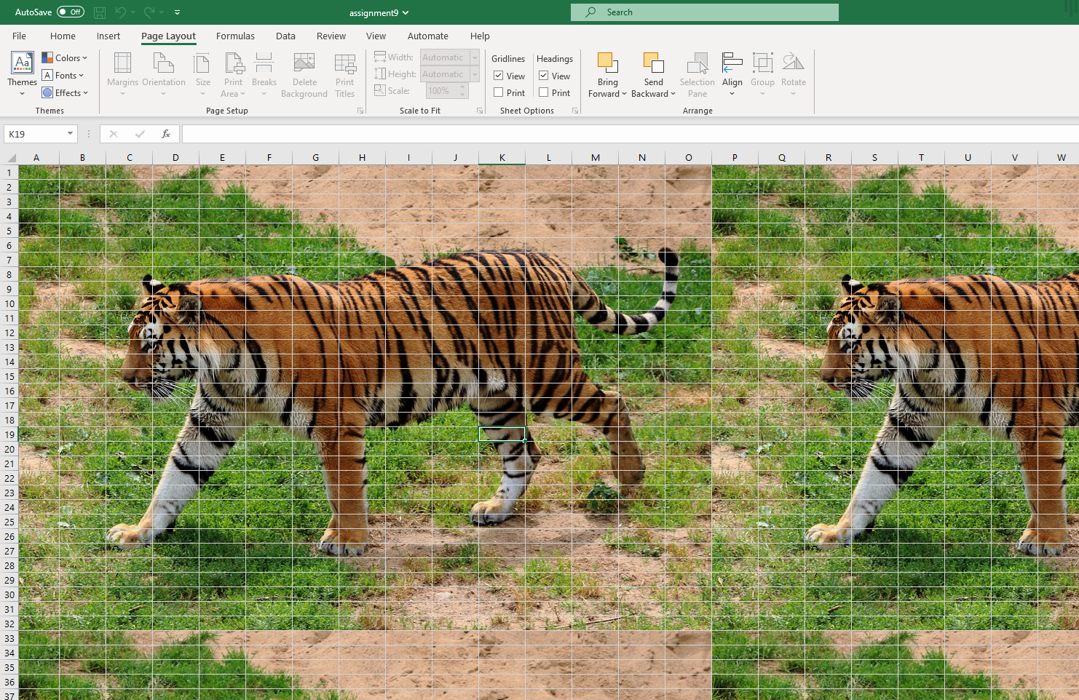

**Q3. What is freeze panes and why do we use freeze panes? Give examples.**

The [Excel](https://www.simplilearn.com/tutorials/excel-tutorial/excel-dashboard) Freeze Panes option allows you to lock your columns and/or rows so that when you scroll down or over to view the rest of your sheet, the column and/or row will remain on the screen

To freeze only the top row, execute the steps mentioned below:

1. In the windows group, go to the View tab, and click Freeze Panes.

Click Freeze Top Row.



**Q 4. What are the different features available within the Freeze Panes command?**

Excel enables three methods to freeze the pane.

1. Freeze Pane
2. Freeze Top Row
3. Freeze First Column

**Q 5. Explain what the different sheet options present in excel are and what they do?**

Options in Sheet Options Dialogue

* Print Area − You can set the print area with this option.
* Print Titles − You can set titles to appear at the top for rows and at the left for columns.
* Print −
  + Gridlines − Gridlines to appear while printing worksheet.
  + Black & White − Select this check box to have your color printer print the chart in black and white.
  + Draft quality − Select this check box to print the chart using your printer’s draft-quality setting.
  + Rows & Column Heading − Select this check box to have rows and column heading to print.
* Page Order −
  + Down, then Over − It prints the down pages first and then the right pages.
  + Over, then Down − It prints right pages first and then comes to print the down pages.